Assignment-3.R
54875
2022-10-10
##############################
### ASSIGNMENT-3 ############
#############################
#PROBLEM-2.16
#A)
library(alr4)
## Loading required package: car
## Loading required package: carData
## Loading required package: effects
## lattice theme set by effectsTheme()
## See ?effectsTheme for details.
scatterplot(log(fertility)~log(ppgdp),UN11)
I have used the scatterplot function here and I had got the solid regression line which is linear and constant in variance. Also, I got the box plots for the selected variables.
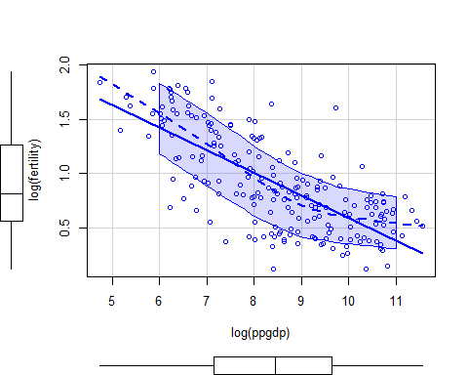
#B)
m1 <- lm(log(fertility) ~ log(ppgdp),UN11)
plot(log(fertility) ~ log(ppgdp),UN11)
abline(m1)
This is the regression model with the two variables fertility and ppgdp in logarithm values and we have computed the fitted line here using abline.
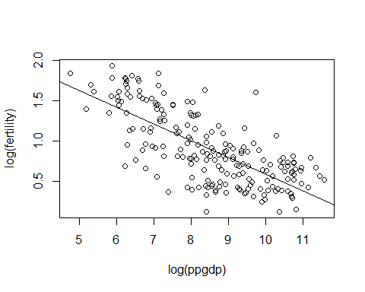
#C)
summary(m1)
##
## Call:
## lm(formula = log(fertility) ~ log(ppgdp), data = UN11)
##
## Residuals:
## Min 1Q Median 3Q Max
## -0.79828 -0.21639 0.02669 0.23424 0.95596
##
## Coefficients:
## Estimate Std. Error t value Pr(>|t|)
## (Intercept) 2.66551 0.12057 22.11 <2e-16 ***
## log(ppgdp) -0.20715 0.01401 -14.79 <2e-16 ***
## ---
## Signif. codes: 0 '***' 0.001 '**' 0.01 '*' 0.05 '.' 0.1 ' ' 1
##
## Residual standard error: 0.3071 on 197 degrees of freedom
## Multiple R-squared: 0.526, Adjusted R-squared: 0.5236
## F-statistic: 218.6 on 1 and 197 DF, p-value: < 2.2e-16
Coefficient of determination is 0.526, which shows us that 52% of variability of values of ppgdp explained on fertility.
#D)
predict <-predict(m1, newdata=data.frame(ppgdp=c(1000)),interval="prediction", level=0.95)
exp(predict)
According to the question we have to predict at a certain point of 1000 in ppgdf which is our assumption and it’s not present in the dataset.
According to the question we have to use the exponential form to predict the plot and the values are
## fit lwr upr
## 1 3.436891 1.869889 6.31707

#E)
win.graph()
with(UN11,plot(log(fertility)~log(ppgdp)))
with(UN11, abline(lm(log(fertility)~log(ppgdp)), lwd=2))
#Plotting in Graph needed points
identify(log(UN11$ppgdp),log(UN11$fertility),tolerance=1,n=3)
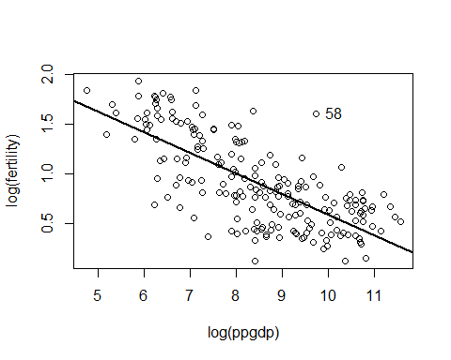
Results of localities of highest and lowest values also values of localities with largest positive and negative residuals.
## [1] 23 58 132
#MAX and MIN Values
print(UN11[UN11$fertility == max(UN11$fertility),][1])
Highest fertility locality:
## region
## ‘Niger’ Africa
print(UN11[UN11$fertility == min(UN11$fertility),][1])
Lowest Fertility locality:
## region
## ‘Bosnia and Herzegovina’ Europe and this is also the largest negative residual locality(-0.7982759).
#Largest Residual value
## Equatorial Guinea
## 0.9559557
#PROBLEM-2
names(salary)
## [1] "degree" "rank" "sex" "year" "ysdeg" "salary"
with(salary, boxplot(year~sex))
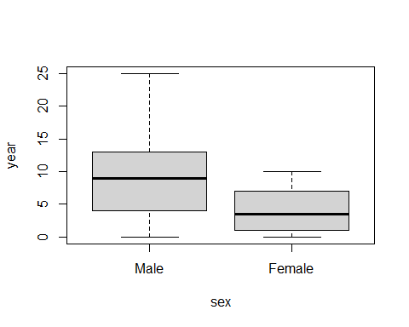
Basic functions between regressors year and sex which contains median(solid middle line inside the box), 1st and 3rd quartiles which is upper line and bottom line of the box.
with(salary, plot(salary~year, pch=19))
with(salary, abline(lm(salary~year),lwd=2))
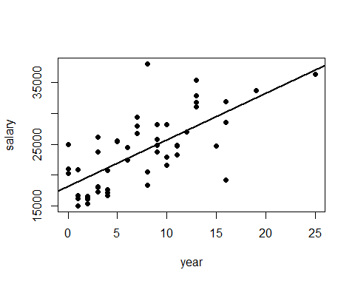
with(salary, plot(salary~year, col=ifelse(sex=="Male", "blue", "red"),pch=20))
data("salary")
with(salary[salary$sex=="Female",], abline(lm(salary~year),col="red",lwd=2))
with(salary[salary$sex=="Male",], abline(lm(salary~year),col="blue",lwd=2))
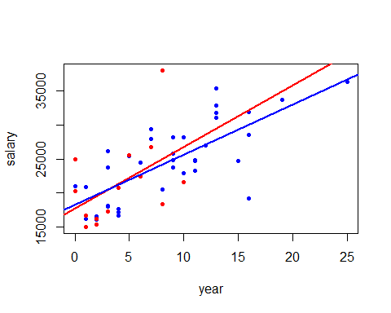
Plotting of mean function with variables year and salary with respect to the sex(male , female). Male observations are in color blue and female is red.
#Confidence interval of 95%
m2 <- lm(salary~sex+year+sex*year,salary)
confint(m2,level = 0.95)
These are the values of confidence intervals of 95%.
## 2.5 % 97.5 %
## (Intercept) 15591.4033 20853.7638
## sexFemale -5189.6645 4048.1558
## year 487.2189 994.8282
## sexFemale:year -608.9700 947.0770

